12

Look at each of the circuits below. For each bulb, tick one box to show if the bulb is lit or not.

a.
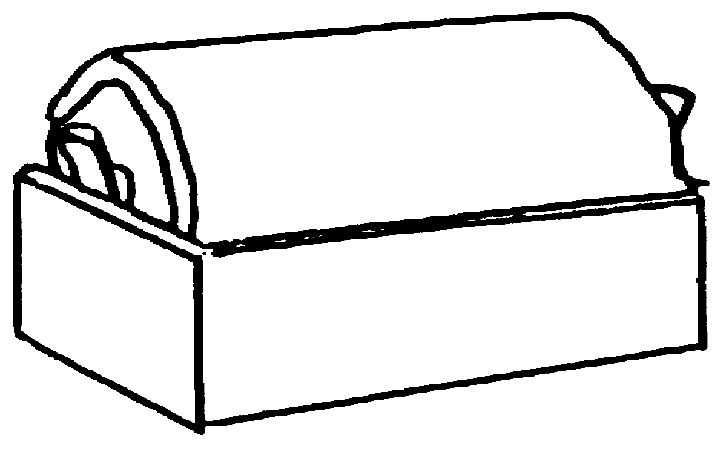
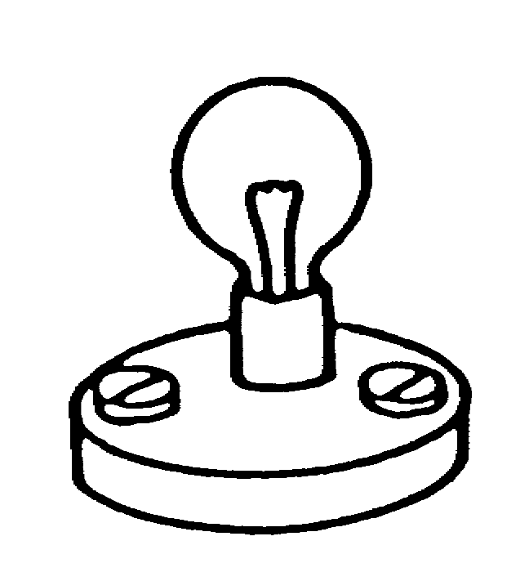

.

not lit
lit
.

not lit
lit

b.
.

not lit
lit
.

not lit
lit

